**SIGNAL GENERATOR USING**

**8051 MICROCONTROLLER**

A

Mini Project Report

Submitted in partial fulfilment of the

Requirements for the award of the Degree of

BACHELOR OF ENGINEERING

IN

COMPUTER SCIENCE & ENGINEERING

By

**AKASH S VORA**

**1602-19-733-126**

**AMITH SOURYA**

**1602-19-733-128**



**Department of Computer Science & Engineering**

**Vasavi College of Engineering (Autonomous)**

**(Affiliated to Osmania University)**

**Ibrahimbagh, Hyderabad-31**

**2021**

**Vasavi College of Engineering (Autonomous)**

**(Affiliated to Osmania University)**

**Hyderabad-500 031**

**Department of Computer Science & Engineering**



**DECLARATION BY THE CANDIDATE**

I, **AKASH S VORA,** bearing hall ticket number, **1602-19-733-126**, hereby declare that the project report entitled **“SIGNAL GENERATOR USING 8051 MICROCONTROLLER”** Department of Computer Science & Engineering, VCE, Hyderabad, is submitted in partial fulfilment of the requirement for the award of the degree of **Bachelor of Engineering** in **Computer Science & Engineering**.

This is a record of bonafide work carried out by me and the results embodied in this project report have not been submitted to any other university or institute for the award of any other degree or diploma.

**Akash S Vora,**

**1602-19-733-126.**

**Vasavi College of Engineering (Autonomous)**

**(Affiliated to Osmania University)**

**Hyderabad-500 031**

**Department of Computer Science & Engineering**



**BONAFIDE CERTIFICATE**

Thisis to certify that the project entitled **“SIGNAL GENERATOR USING 8051 MICROCONTROLLER”** being submitted by **AKASH S VORA,** bearing **1602-19-733-126,** in partial fulfilment of the requirements for the award of the degree of Bachelor of Engineering in Computer Science & Engineering is a record of bonafide work carried out by him/her under my guidance.

**Dr. Marella Shanmukhi**

**Professor**

**Dept. of CSE**

**ACKNOWLEDGEMENT**

With immense pleasure, we record our deep sense of gratitude to our guide Dr. Marella Shanmukhi, Professor, Vasavi College of Engineering, Hyderabad, for the valuable guidance and suggestions, keen interest and thorough encouragement extended throughout the period of the project work. I consider myself lucky enough to be part of this project. This project would add as an asset to my academic profile.

We express our thanks to all those who contributed for the successful completion of our project work.

**ABSTRACT**

Signal generator that generates different shapes of waveforms over a wide range of frequencies, is an important instrument in testing and operating different kinds of electrical equipments. It can provide a wide range of controlled amplitudes, and maintain constant amplitude as the frequency is varied.

It is widely used in engineering applications especially in control field. A common feature of a microcontroller based signal generator allows the user to select a waveform type (sine, square, and triangle) and to select the waveform frequency and amplitude. In this project, 8051 microcontroller is used to generate the signal and to display the frequency and the amplitude of the generated signal.

**TABLE OF CONTENTS**

**Page No.**

1. **List of Figures …………………………………………………..1**
2. **Introduction……………………………………………………..2**
   1. **Overview…………………………………………………....3**
   2. **Applications………………………………………………..11**
   3. **Simulator Used…………………………………………….12**
   4. **Objective…………………………………………………...12**
3. **System Requirements .…………………...................................13**
4. **Implementation……..………………………………………….14**
5. **Output of the Program ………………………………………..25**
6. **Conclusion…………………….………………………………..29**
7. **References ………………………………………………...........29**

**LIST OF FIGURES**

Figure 2.1.1 Types of Waveforms……………………………………………….3

Figure 2.1.2 Interfacing Diagram………………………………………………..4

Figure 2.1.3 Triangular Wave……………………………………………………4

Figure 2.1.4 Flowchart for the generation of Triangular Wave………………….5

Figure 2.1.5 Square Wave………………………………………………………..6

Figure 2.1.6 Flowchart for the generation of Square Wave……………………...7

Figure 2.1.7 Sine Wave…………………………………………………………..8

Figure 2.1.8 Flowchart for the generation of Sine Wave ………………………..9

Figure 2.1.9 Flowchart for LCD Interfacing…………………………………….10

Figure 2.2.1 Example of signal generator………………………………………..11

Figure 2.3.1 EdSim51……………………………………………………………12

**INTRODUCTION**

A signal generator is one of a class of electronic devices that generates electronic signals with set properties of amplitude, frequency, and wave shape. These generated signals are used as a stimulus for electronic measurements, typically used in designing, testing, troubleshooting, and repairing electronic or electroacoustic devices.

The main idea behind the signal generator is Digital to Analog Conversion (DAC). In this project, we use 8-bit DAC 0808. This IC converts digital data into equivalent analog current.

**2.1 OVERVIEW**

In our project, the letters “SIGNAL GENERATOR” are first displayed on the 16*2 LCD display.

Next, a user needs to press a number on the keypad. If the user presses 1, 2 or 3, a triangular wave, a square wave, and a sine wave is generated respectively.

All the waves will be displayed after clicking on the DAC (Digital Analog Converter) button on the EdSim51 simulator.

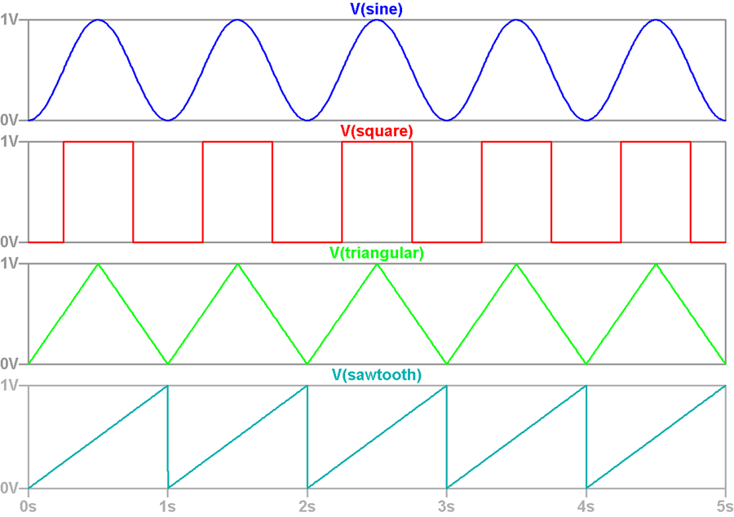

Figure 2.1.1

The following figure shows how the DAC0808 is connected to 8051 microcontroller.

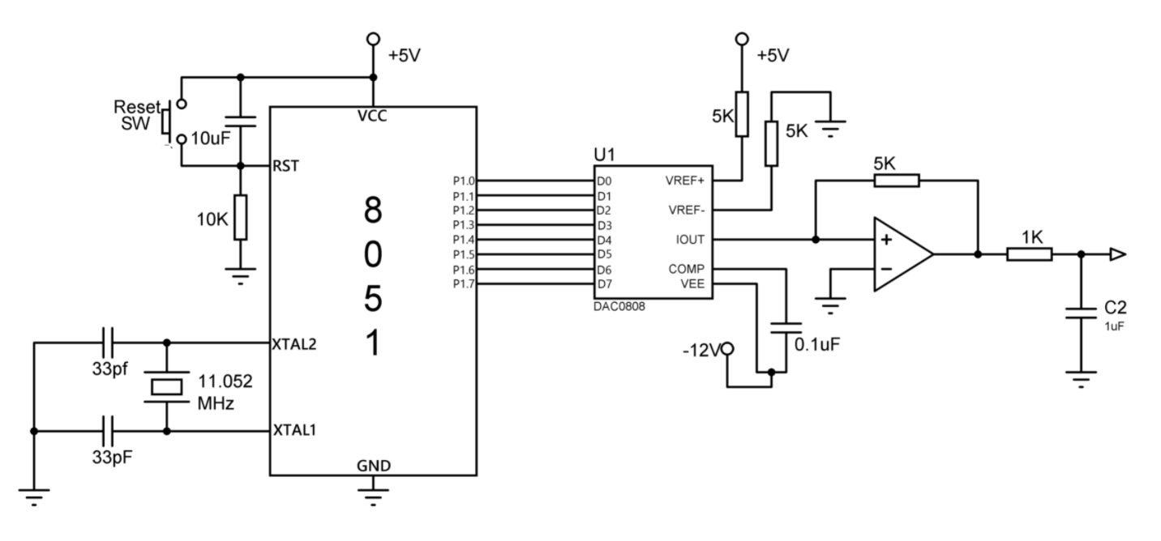

Figure 2.1.2

* **Types of Waveforms :**

In this project, 3 types of waveforms are generated.

* A **triangular wave** is a non-sinusoidal waveform named for its triangular shape. It is a periodic, piecewise linear, continuous real function. It contains only odd harmonics.

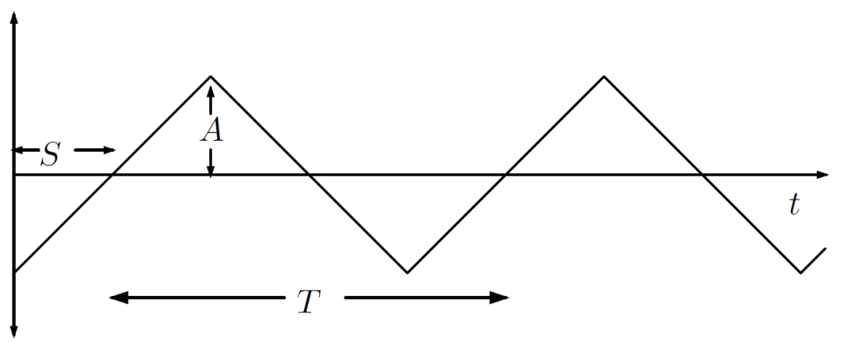

Figure 2.1.3

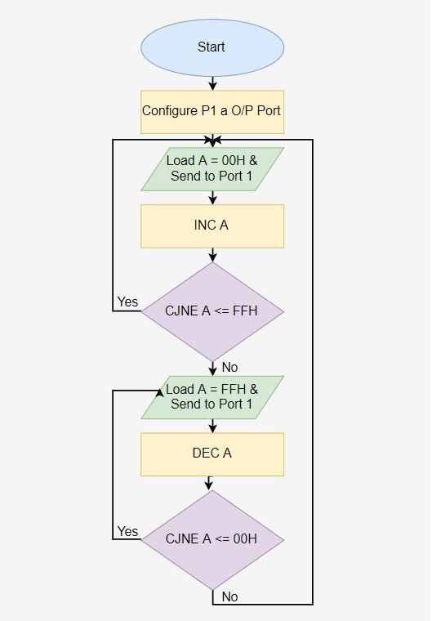Figure 2.1.4

The above flowchart describes the algorithm used for the generation of triangular wave using 8051 microcontroller.

* A **square wave** is a non-sinusoidal periodic waveform in which the amplitude alternates at a steady frequency between fixed minimum and maximum values, with the same duration at minimum and maximum.

It is a special case of a [pulse wave](https://en.wikipedia.org/wiki/Pulse_wave) which allows arbitrary durations at minimum and maximum. The ratio of the high period to the total period of a pulse wave is called the [duty cycle](https://en.wikipedia.org/wiki/Duty_cycle). A true square wave has a 50% duty cycle (equal high and low periods). These are often encountered in [electronics](https://en.wikipedia.org/wiki/Electronics) and [signal processing](https://en.wikipedia.org/wiki/Signal_processing), particularly [digital electronics](https://en.wikipedia.org/wiki/Digital_electronics) and [digital signal processing](https://en.wikipedia.org/wiki/Digital_signal_processing).

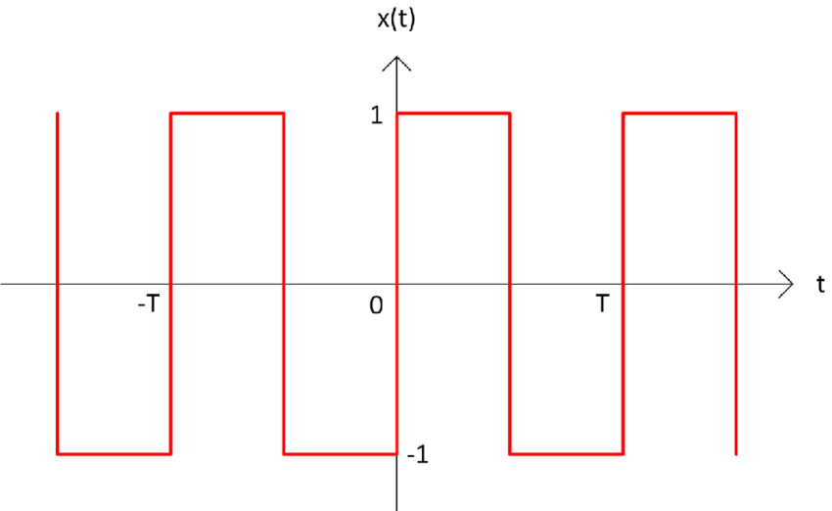

Figure 2.1.5

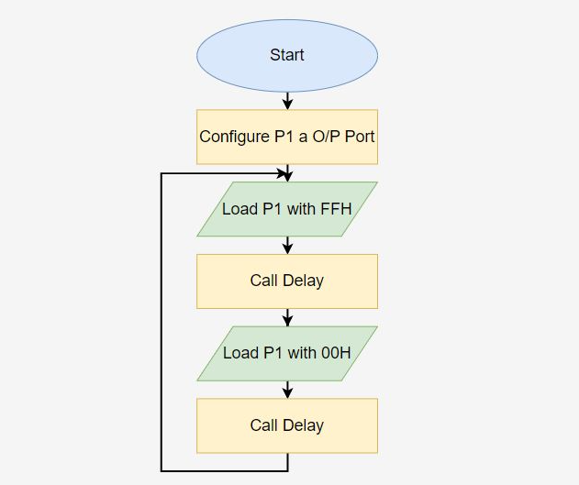

Figure 2.1.6

The above flowchart describes the algorithm used for the generation of square wave using 8051 microcontroller.

* A **sine wave** is a mathematical curve that describes a smooth periodic oscillation. It is a continuous wave and is important in physics because it retains its wave shape when added to another sine wave of the same frequency and arbitrary phase and magnitude.

This [wave](https://en.wikipedia.org/wiki/Wave) pattern occurs often in nature, including [wind waves](https://en.wikipedia.org/wiki/Wind_wave), [sound](https://en.wikipedia.org/wiki/Sound) waves, and [light](https://en.wikipedia.org/wiki/Light) waves. The human [ear](https://en.wikipedia.org/wiki/Ear) can recognize single sine waves as sounding clear because sine waves are representations of a single [frequency](https://en.wikipedia.org/wiki/Frequency) with no [harmonics](https://en.wikipedia.org/wiki/Harmonic).

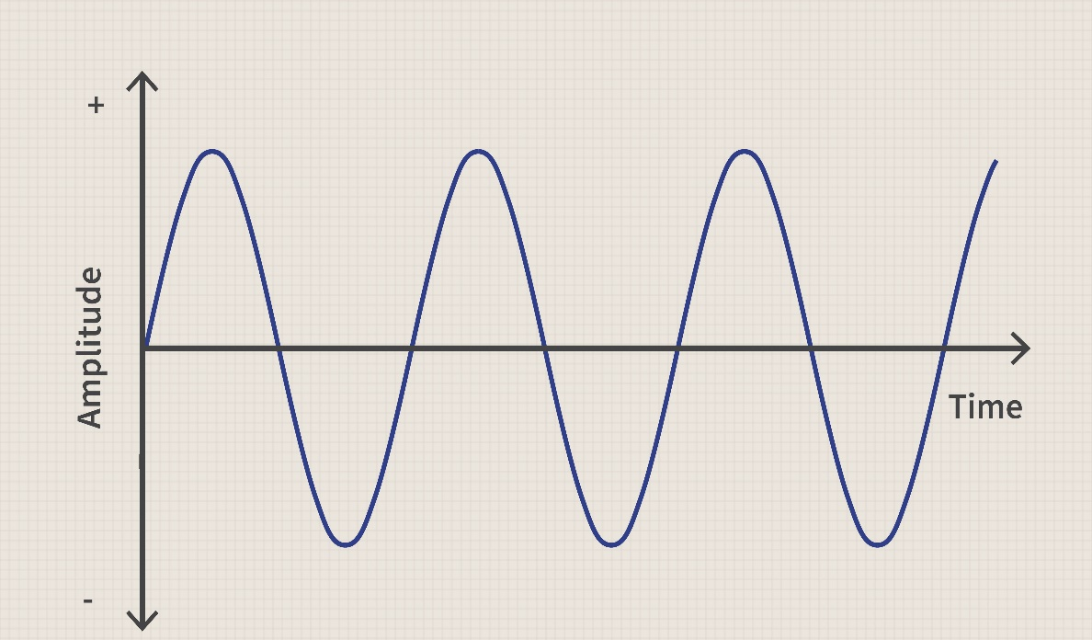

Figure 2.1.7

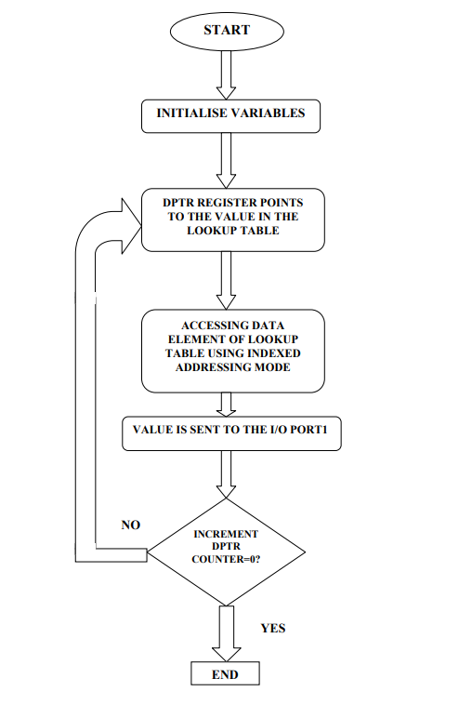

Figure 2.1.8

The above flowchart describes the algorithm used for the generation of sine wave using 8051 microcontroller.

* **LCD Interfacing with 8051 used to display data on the 16*2 LCD :**

The LCD Module shares port 1 with the LEDs and DAC. This LCD module is a simulation of the Hitachi HD44780 and is interfaced to the 8051 in 4-bit mode.

P1.7 through P1.4 are connected to DB7 through DB4, while P1.3 is connected to the register-select pin and P1.2 is connected to the enable pin.

By default, the module is interfaced in 4-bit mode. However, the lower four data bits (DB3 through DB0) are also available (on P1.3 through P1.0). If the user wishes to write to the module in 8-bit mode, RS and E should be remapped to other port pins, using the DI button at the top left of the peripheral panel.

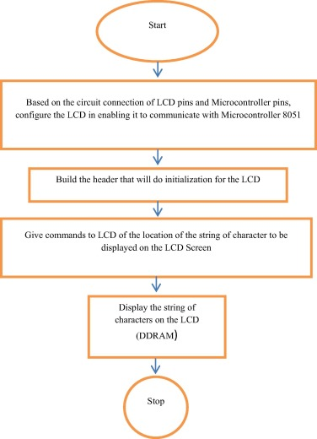

Figure 2.1.9

The above flowchart describes the algorithm used for the displaying a string on the 16x2 LCD of 8051 microcontroller.

**2.2 APPLICATIONS**

* These waveforms are used to analyze any electronics system.
* Different types of waveforms are generated with the help of this system like sine wave, triangular wave and square wave.
* Here, we can generate waveform with minimal use of electronics components. The system provides good accuracy because of the programmable device like 8051 microcontroller.
* These waveforms are digitally-controlled to achieve the required wave shape.
* These generated signals are used as a stimulus for electronic measurements, typically used in designing, testing, troubleshooting, and repairing electronic or electroacoustic devices.

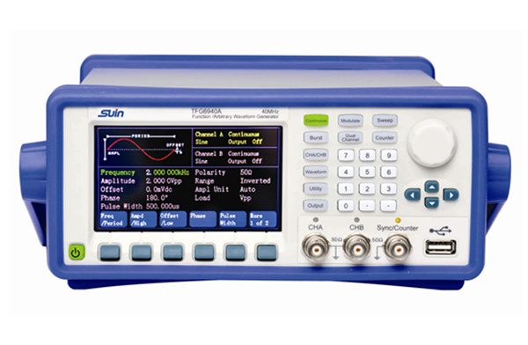

Figure 2.2.1

**2.3 SIMULATOR USED**

* The EdSim51 is a popular simulator for 8051 microcontroller.
* A virtual 8051 is interfaced with virtual peripherals such as a keypad,  
  motor, display, UART, etc., In this, we can write 8051 assembly code, step through the code and observe the effects each line has on the internal memory and the external peripherals.
* One major advantage of using EdSim51 simulator is that it shows graphical representations of peripherals that can be used interactively to communicate with the 8051.

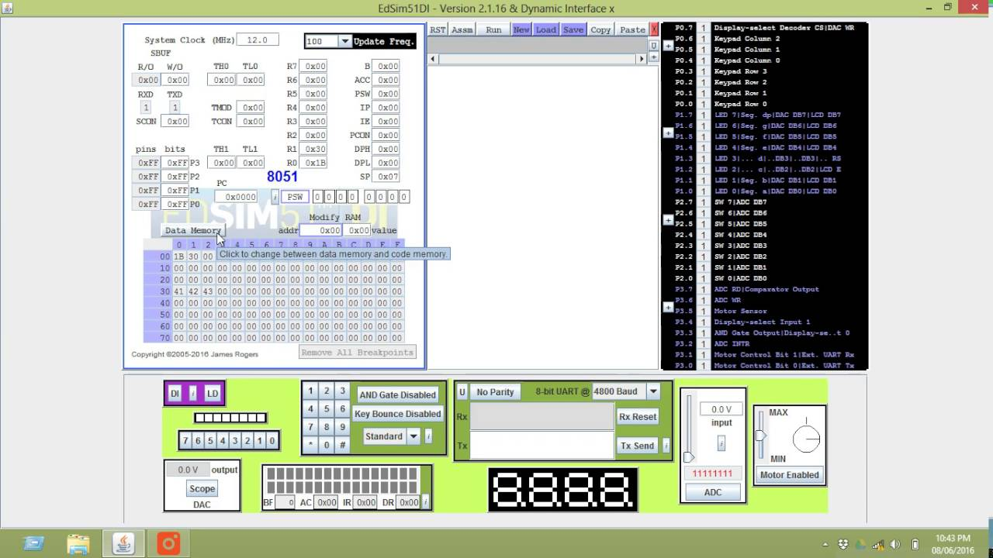

Figure 2.3.1

**2.4 OBJECTIVE**

To build a signal generator that generates different types of waveforms using 8051 microcontroller.

**SYSTEM REQUIREMENTS**

**Hardware:**

* Minimum RAM required: 1 GB
* Input devices: Mouse, Keyboard
* Output devices: Monitor

**Software:**

* EdSim51 Simulator
* Windows 7 or above

**IMPLEMENTATION**

;DAC INTERFACING IN 8051

;MICROCONTROLLER PROJECT

;SIGNAL GENERATOR USING DAC

;"SIGNAL GENERATOR" IS DISPLAYED

;ON THE 16*2 LCD DISPLAY

;NEXT IS THE MENU PROGRAM

;IF USER ENTERS 1 - A TRIANGULAR

;WAVE IS GENERATED

;IF USER ENTERS 2 - A SQUARE WAVE

;IS GENERATED

;IF USER ENTERS 3 - A SINE WAVE

;IS GENERATED

MOV 30H, #'S'

MOV 31H, #'I'

MOV 32H, #'G'

MOV 33H, #'N'

MOV 34H, #'A'

MOV 35H, #'L'

MOV 36H, #' '

MOV 37H, #'G'

MOV 38H, #'E'

MOV 39H, #'N'

MOV 3AH, #'E'

MOV 3BH, #'R'

MOV 3CH, #'A'

MOV 3DH, #'T'

MOV 3EH, #'O'

MOV 3FH, #'R'

MOV 40H, #0 ;END OF DATA MARKER

;INITIALIZE THE DISPLAY

CLR P1.3 ;CLEAR RS - INDICATES

;THAT THE INSTRUCTIONS ARE BEING

;SENT TO THE MODULE

;FUNCTION SET

CLR P1.7

CLR P1.6

SETB P1.5

CLR P1.4

SETB P1.2

CLR P1.2

;WAIT FOR BF TO CLEAR

CALL delay

SETB P1.2

CLR P1.2

SETB P1.7

SETB P1.2

CLR P1.2

CALL delay

;ENTRY MODE SET

CLR P1.7

CLR P1.6

CLR P1.5

CLR P1.4

SETB P1.2

CLR P1.2

SETB P1.6

SETB P1.5

SETB P1.2

CLR P1.2

;WAIT FOR BF TO CLEAR

CALL delay

;DISPLAY ON/OFF CONTROL

;THE DISPLAY IS TURNED ON,

;THE CURSOR IS TURNED ON AND

;BLINKING IS TURNED ON

CLR P1.7

CLR P1.6

CLR P1.5

CLR P1.4

SETB P1.2

CLR P1.2

SETB P1.7

SETB P1.6

SETB P1.5

SETB P1.4

SETB P1.2

CLR P1.2

;WAIT FOR BF TO CLEAR

CALL delay

;SEND DATA

SETB P1.3

;DATA TO BE SENT TO LCD

;IS STORED IN 8051 RAM,

;STARTING AT LOCATION 30H

MOV R1, #30H

loop:

;MOVE DATA POINTED BY R1 TO A

MOV A, @R1

JZ finish

;IF A IS 0,

;THEN END OF DATA HAS BEEN

;reached - JUMP OUT OF LOOP

CALL sendCharacter

;SEND DATA IN A TO LCD MODULE

INC R1

JMP loop

;REPEAT

finish:

JMP START

sendCharacter:

MOV C, ACC.7

MOV P1.7, C

MOV C, ACC.6

MOV P1.6, C

MOV C, ACC.5

MOV P1.5, C

MOV C, ACC.4

MOV P1.4, C

SETB P1.2

CLR P1.2

MOV C, ACC.3

MOV P1.7, C

MOV C, ACC.2

MOV P1.6, C

MOV C, ACC.1

MOV P1.5, C

MOV C, ACC.0

MOV P1.4, C

SETB P1.2

CLR P1.2

CALL delay

delay:

MOV R0, #50

DJNZ R0, $

RET

SINE:

DB 127,160,191,217,237,250,255,250,237,217,191,160,127,94,63,37,17,4,0,4,17,37,63,94,127

TRIANGULAR:

CLR A ;CLR ACCUMULATOR

CLR P0.7 ;CLR DAC WR

LOOP2:

MOV P1,A

ADD A,#3 ;ADD 3 TO A

;COMPARE A AND #OFFH

;IF NOT EQUAL, JUMP TO LOOP2

CJNE A,#0FFH,LOOP2

LOOP1:

MOV P1,A

SUBB A,#3 ;SUBB FROM A

;COMPARE A AND #00H

;IF NOT EQUAL, JUMP TO LOOP1

CJNE A,#00H,LOOP1

JMP LOOP2 ;JUMP TO LOOP2

RET ;RETURN

SQUARE:

CLR A ;CLR ACCUMULATOR

CLR P0.7 ;CLR DAC WR

BACK:

MOV A,#00H ;MOV #00H TO A

MOV P1,A

CALL B1

MOV A,#0FFH

MOV P1,A

CALL B1

LJMP BACK ;TRANSFERS PROGRAM EXECUTION TO BACK

B1: MOV R2,#02FH ;MOV #02FH TO R2

B2: DJNZ R0,B2

RET

SINWAVE:

CLR A ;CLR ACCUMULATOR

UP:

MOV DPTR,#SINE

MOV R0,#24 ;MOV 24 TO R0

CLR P0.7 ;CLR DAC WR

LABEL:

MOVC A,@A+DPTR

;MOVES A BYTE FROM

;PROGRAM MEMORY

;TO ACCUMULATOR

MOV P1,A

CLR A

INC DPTR

DJNZ R0,LABEL ;DECREMENTS R0

;IF R0 IS NOT ZERO, JUMP BACK TO LABEL

SJMP UP

colScan:

JNB P0.4,THREE

JNB P0.5,TWO

JNB P0.6,ONE

RET

gotKey:

SETB F0

RET

ONE:

SETB P3.3

SETB P3.4

MOV P1, #11111001B

CALL TRIANGULAR

JMP gotKey

TWO:

SETB P3.3

SETB P3.4

MOV P1, #10100100B

CALL SQUARE

JMP gotKey

THREE:

SETB P3.3

SETB P3.4

MOV P1, #10110000B

CALL SINWAVE

JMP gotKey

START:

CLR P0.3 ;MAKING TOP ROW

CALL colScan

JNB F0,START

END

**OUTPUT OF THE PROGRAM**

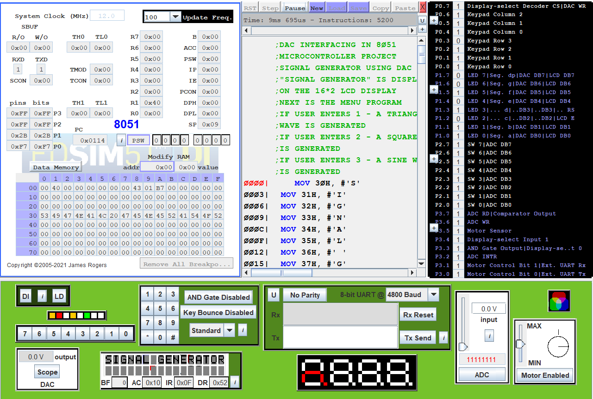

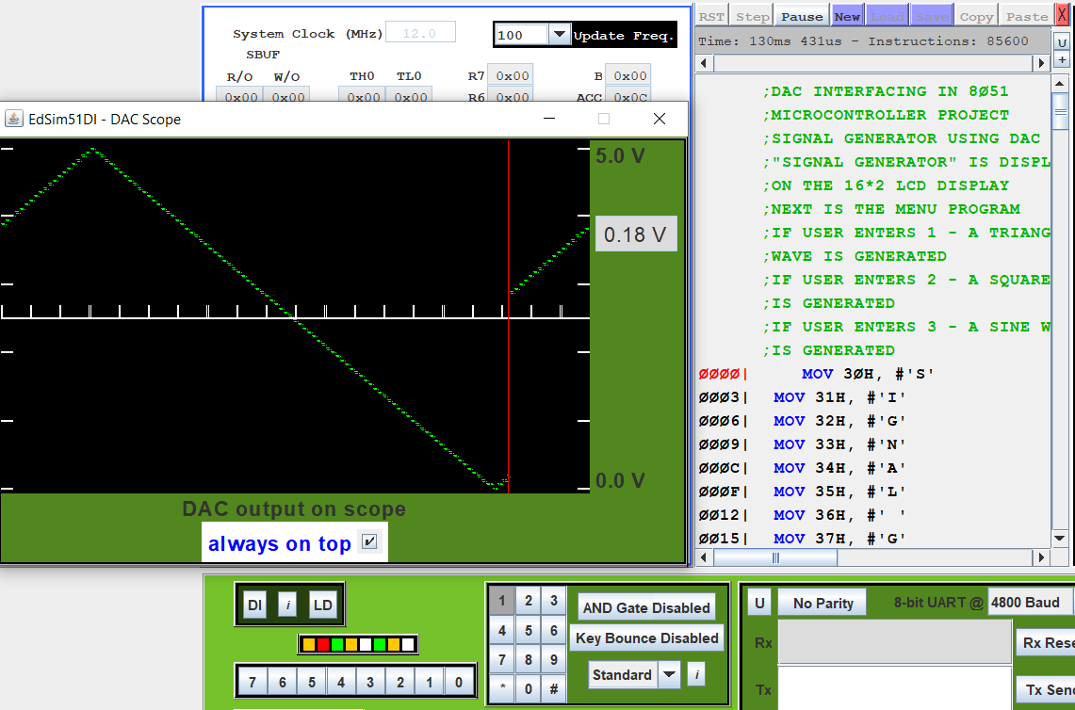

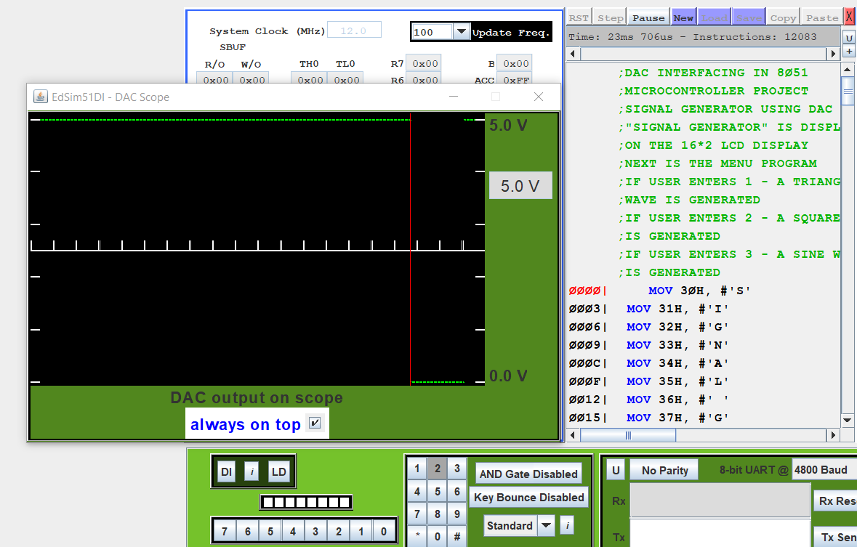

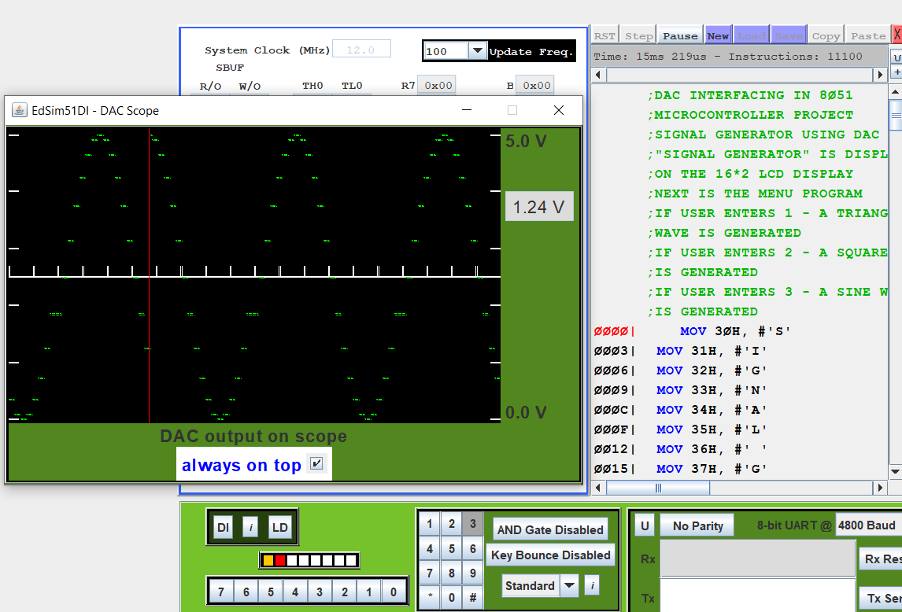

**CONCLUSION**

A signal generator is successfully built using the 8051 microcontroller. This signal generator delivers an accurate calibrated range. It provides a signal that can be adjusted according to the frequency, output voltage, waveform and modulation.

**REFERENCES**

* The 8051 Microcontroller Architecture, Programming and Applications by Kenneth J Ayala, Penram International (2007)
* <https://www.edsim51.com/>
* <https://en.wikipedia.org/wiki/Main_Page>
* <https://www.tutorialspoint.com>
* <https://www.youtube.com>